|  |  |
| --- | --- |
| ***Tank Cleaning*** |  |
| The refining and hydrocarbon processing industry is ready for the new wave of vessel cleaning technology. **Ivey-so**l® is a patented product that greatly reduces downtime and improves overall safety while providing immediate cost savings for any tank cleaning process.  **Ivey-sol** is non-toxic, non-corrosive, non-hazardous, 100% biodegradable and also non-skin sensitizing.  **Ivey-sol** is simply mixed with water (at 3 to 6%) to form micelles “chemical cocoon-like encapsulations” which seek and surround the various forms of hydrocarbons.  **Ivey-sol** can be premixed or introduced into the water and can be sprayed, steamed, circulated or left to stand. |  |

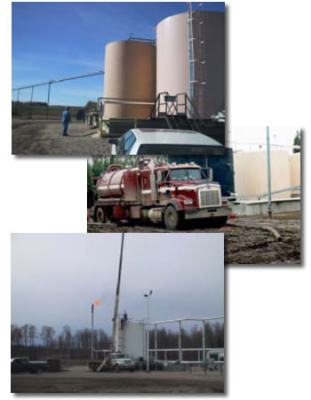

**SOIL/GROUNDWATER REMEDIATION**

|  |  |  |  |
| --- | --- | --- | --- |
| ***Surfactant Enhanced Remediation*** | |  | |
| **SER-Surfactant Enhanced Remediation**http://www.iveyinternational.com/images/SM.gif  In-situ and ex-situ application processes to liberate contaminants making them more ‘hydraulically-available’ for mass removal and/or treatment.  **SER** improves in-situ pump and treatment, and/or ex-situ soil washing type applications by >400%. This process could also be used for tank cleaning, vapour suppression, and oil recovery from oil sands or oil shales. | |  | |
|
| ***Surfactant Enhanced Bioremediation*** | |  | |
| **SEB-Surfactant Enhanced Bioremediationhttp://www.iveyinternational.com/images/SM.gif**  In-situ and ex-situ application processes to liberate contaminants making them more ‘bio-available’ for microbial (bacteria) degradation.  **SEB** improves both in-situ and/or ex-situ bioremediation treatment by 40 to 60% or more.  **SEB** is applicable for both warm and cold temperature and climate site applications. | |  | |
|
| ***Surfactant Enhanced Chemicalization*** | |  | |
| **SEC_Surfactant Enhanced Chemicalization**http://www.iveyinternational.com/images/SM.gif  In-situ and ex-situ application processes to liberate contaminants making them more ‘chemically available’ for chemical oxidation by chemical agents. **SEC-Surfactant Enhanced Chemicalization**http://www.iveyinternational.com/images/SM.gif improves the availability of the contaminants to the chemical agents commonly employed to affect in-situ and/or ex-situ chemical oxidation by 40 to 80% or more. The oxidation of non-target compounds (i.e., metals, natural products, and bacteria) is the greatest drawback to chemical oxidant treatment.  **Ivey-sol®** helps overcome this limitation by increasing contact between contaminants and oxidants improving the oxidation rate of target compounds. This process may also be modified for application with chemical reducing agents in reductive dechlorination. | |  | |
|
| ***MTBE Remediation*** |  | |
| MTBE (Methyl Tertiary Butyl Ether) Groundwater Remediation using SER Ivey-sol Technology  Ivey International Inc. recently developed technology, which is an integral part of the Ivey-sol process that is capable of increasing the solubility and rate of MTBE recovery from ground water by greater than 740%.  With more than 15% of the community drinking water supplies impacted with MTBE in the USA; this break through will prove very important in current MTBE clean-up efforts, and the future protection of community drinking water supplies. |  | |

***OTHER Remediation***

***Heavy Metals (Atomisol™)***

***NORMs***



